Determine the Relationship Between the Training Hours and the Performance of the Players

Aayush Nayak
Karan Bhatt
Nischya Lingthep
Westcliff University
DATA 200: Applied Statistical Analytics
Professor Regmi
January 19, 2026

Determine the Relationship Between the Training Hours and the Performance of the Players
This paper has researched the relationship between performance of a player and the number of training hours a week by deciding out the strength and skill scores. The capacity of these variables to predict was determined using a multiple linear regression equation. The assumptions of regression were checked by conducting diagnostic tests. These results have revealed that the hours of training, strength score, and performance of skills were important predictors of the performance and the model satisfied the significant statistical assumptions.
The issue of what factors contribute to the difference in athletic performance is a major issue of concern in the field of sports science. The aspects include physical strength, training load and technical skills which have so far been considered as being the key determinants of the outcome of performance. With the help of regression analysis, an investigator is able to explore the impact of multiple predictors simultaneously (Regression analysis, n.d.). In the paper, the linear regression is utilized to investigate the correlation between the hours of training and performance when the levels of strength and skill are considered.
Method
Data
The data set is simulated data which is realistic and concerned with sports performance like:
- Training hours per week
- Strength score
- Skill score
- Overall performance score
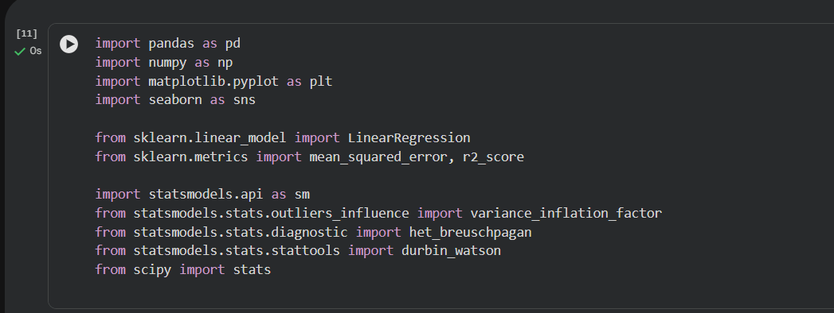
Procedure
Python libraries such as, Pandas, NumPy, Statsmodels and Scikit-learn were used to do the analysis. Regression modelling and diagnostic testing and correlation were conducted.
Results
Correlation Analysis
With the assistance of a correlation heatmap, the variables relationships were studied.
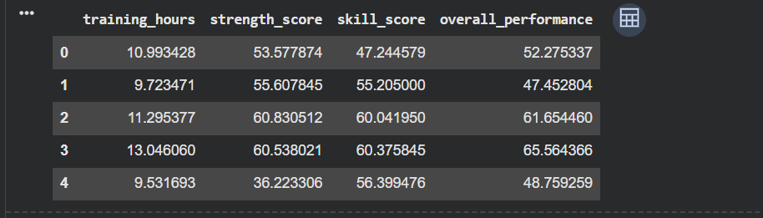
Interpretation:
All the predictors were in positive relationship with the performance meaning there is positive relationship between more training and physical ability and the performance.
Checking Linearity (Scatter Plots)
Scatter plots of predictors VS performance were also drawn.
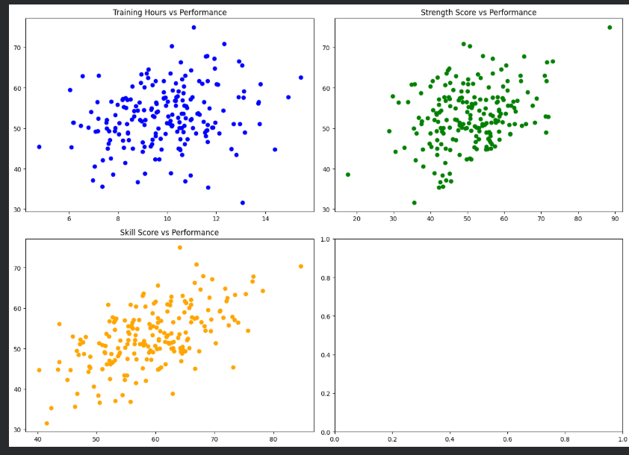
Interpretation:
Each of the predictors showed an upward linear correlation with performance that confirms linearity assumption.
Multiple Linear Regression
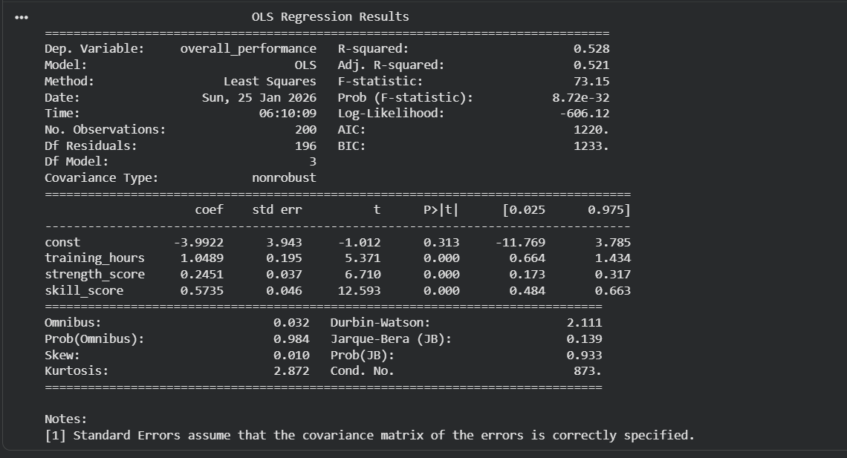
The multiple regression was done in order to predict training hours performance, strength, and skill.
- The significance of the model was also high (p =.001).
- The predictors explain the big percentage used to describe the performance variance which occurs in R2.
- It was found that there was a positive correlation between the number of hours of training and the performance: the more the training, the more the performance.
- Other foretellers were mightiness and ability.
The regression is usually utilized in the process of approximating the relationships between variables ( Regression analysis, n.d.).
Residuals vs Fitted Plot
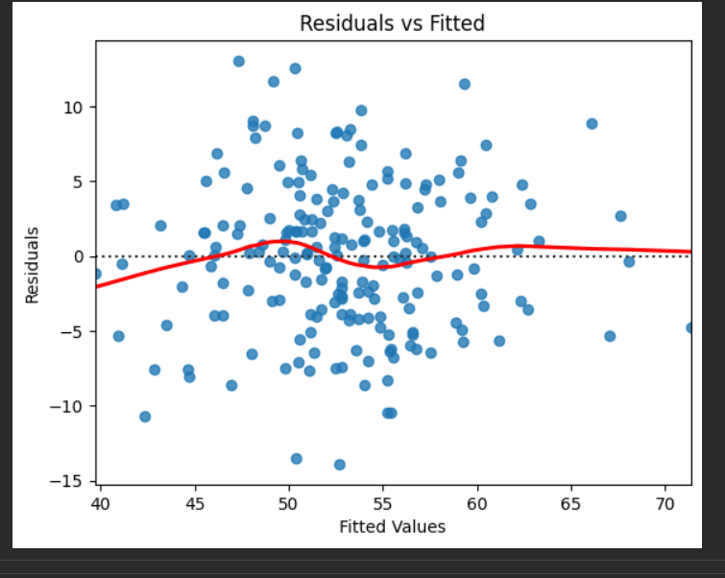
Interpretation:
The scatter plot of residues was random and this implied the linearity, as well as the equal variance.

Q-Q Plot (Normality)
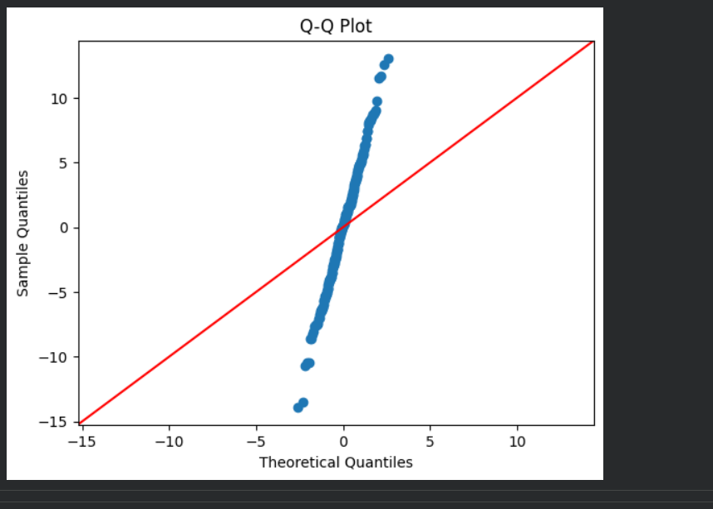
Interpretation:
The points were followed reasonably on the diagonal line, meaning that the residues would be approximately normally distributed.

Histogram of Residuals
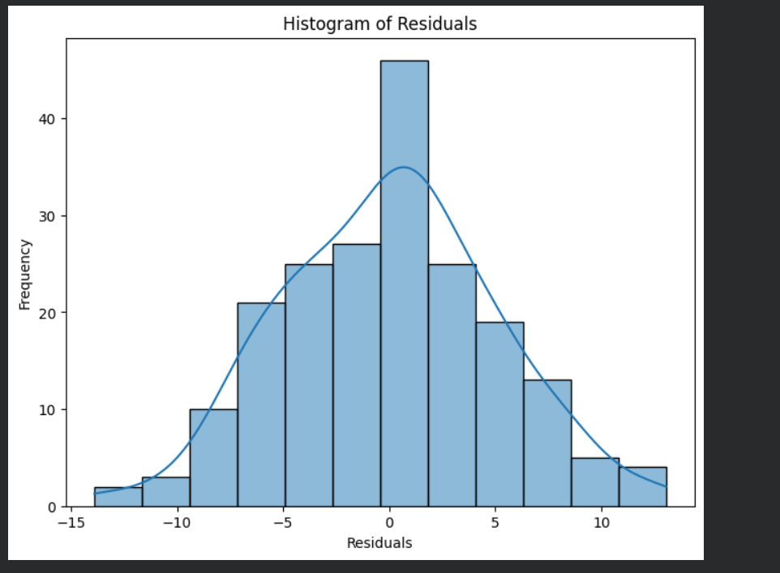
Interpretation:
In order to graphically check whether the residual are normally distributed or not, a graph of a histogram of the residues was plotted. Linear regression can be described as the condition in which case the data is considered to be normal, and it justifies the potential statistical inference of the outputs. The histogram displayed a bell distribution which was concentrated at the point of zero and therefore the majority of the errors in prediction are small and symmetrically distributed at the zero point. The abnormalities of normality might be marginal but regression analysis tends to allow moderate abnormalities in the normalcy especially with large sample. In this way, it is possible to make adequate model assumptions with regard to residual distribution.
Box Plot of Residuals
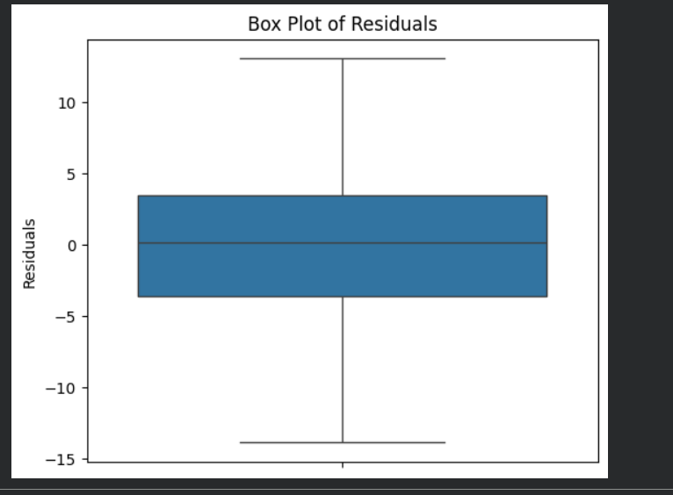
Interpretation:
A boxplot of the residual was used to see the existence of outliers and the distribution of the prediction errors. The boxplot has shown that there are few extreme values which are among the mild values that may happen in the inter quartile of the plot. This indicates that, this model does not respond highly to abnormal or extreme values. The distribution around zero is rather equal, which allows also concluding that the prediction errors are not skewed toward either side. As such, the residual distribution indicates that the regression model is able to provide consistent and accurate estimates.
Conclusion
The multiple linear regression analysis has pointed to imperatively that hours of training, the score of the strength and the score of skills were significant predictors of performance of the players. The model has outlined a considerable level of model line variance in performance and it can be said that systematized training along with physical and technical ability is important in enhancing athletic performance. The results of the diagnostic showed that most of the key regression data were fulfilled: the distribution of the residuals were randomly distributed with the same variances, the measure of multicollinearity among the predictors was not large, the residual distribution was normal, and the results of the autocorrelation were not significant. The occurrence of the extra visual assumptions was recreated with the help of the histograms and the box analytics that did not demonstrate any extreme values and allowed observing the stable model behavior. These outcomes point to the fact that an increase in the time that is devoted to the process of training and improvement of the strength and technical abilities has a strong potential to impact the improvement in the output of the players. Regression strategy helped reach the model of the performance results and potentially provide a relevant guideline that can be used in further sports analytics research and assessments of training programs.

Reference
ziya07. (n.d.). Athlete injury and performance dataset [Dataset]. Kaggle. https://www.kaggle.com/datasets/ziya07/athlete-injury-and-performance-dataset

